Supplementary Figures and Notes
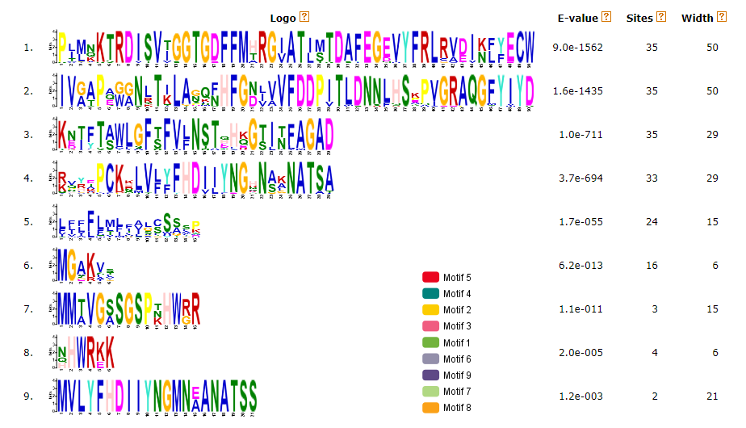Supplemental Figure S1. Sequence logos of conserved motifs in PDH1 protein sequences identified by Multiple Em for Motif Elicitation (MEME, https://meme-suite.org/meme/tools/meme). Motif colours in legend correspond to conserved blocks in Figure 1.

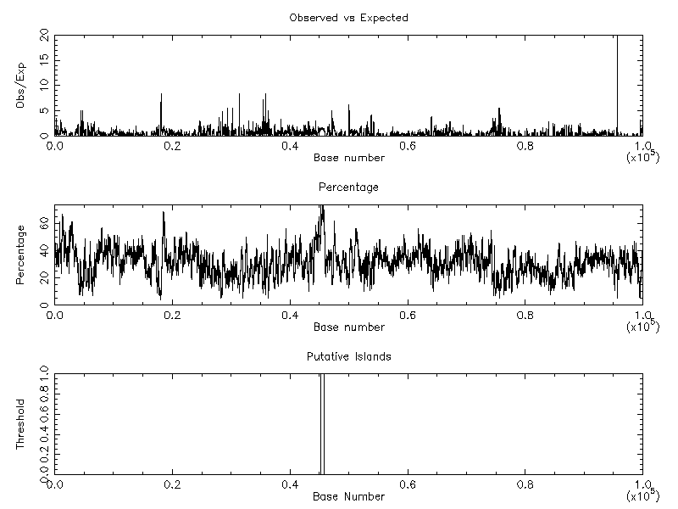
Supplemental Figure S2: Example CpG plot generated by EMBOSS for GmPDH1 genomic context (50kb upstream and downstream of transcriptional start site). The ‘island’ shown at the bottom is within GmSCL15, additional information available at Supplemental Table S4.

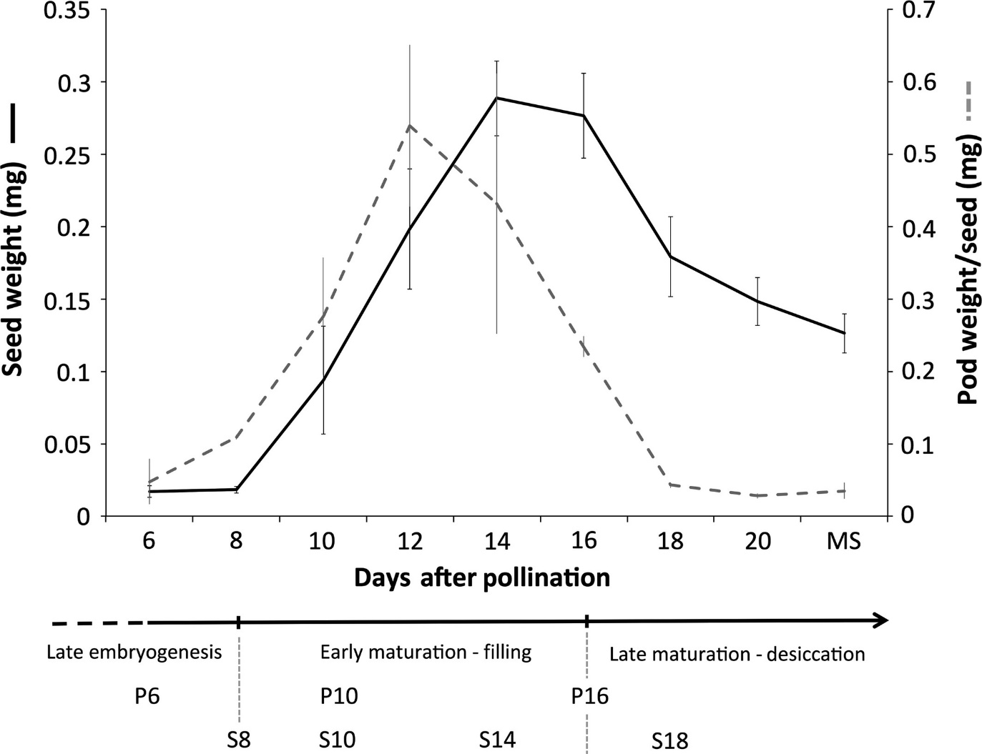
Supplemental Figure S3: Timeline of black-eyed pea pod and seed development from late embryogenesis to maturity, with key pod development stages studied in Figure 3 indicated at the bottom (P6/P10/P16). Image taken directly from Yao et al. 2016 unaltered, additional information available at DOI: 10.1111/tpj.13279.

Appendix S1. All non-Glycine phaseoloids possess a second SCL15 gene annotated elsewhere in the genome, which is adjacent to a ‘HVA22-like protein’ (HVA22) in all cases except V. radiata (Table SX). G. max possesses paralogs of the SCL15-HVA22 dyad as a result of the Glycine specific whole genome duplication. The SCL15-HVA22 appears to have been lost in other legume clades including the IRLC (P. sativum, M. trunculata) and genistoids (L. albus) for which no matching annotation was present.
Appendix S2. The only other pod specific (<100 FPKM in every non-pod tissues), ultra-high expressed gene in mature pod shells (16dap), Vigun09g047400, is annotated as an ‘Unknown protein’. When comparing the genic sequence of Vigun09g047400, the only BLAST hit (E-value = 5.40e-62 and E-value = 8.91e-70 for both exons) in the other legume genomes was LOC108318781, a ‘Repetitive proline-rich cell wall protein 1-like’ gene on an unplaced pangenome scaffold (NW_016152098.1) in V. angularis.

